Close the Loop Survey Summary for Spring 2012 (first use of Seaport 3 data) N=29

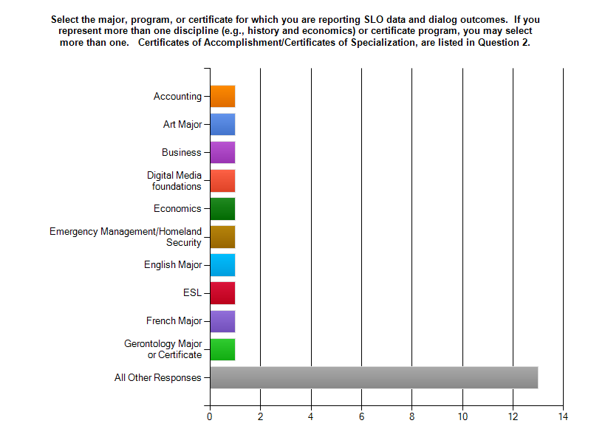
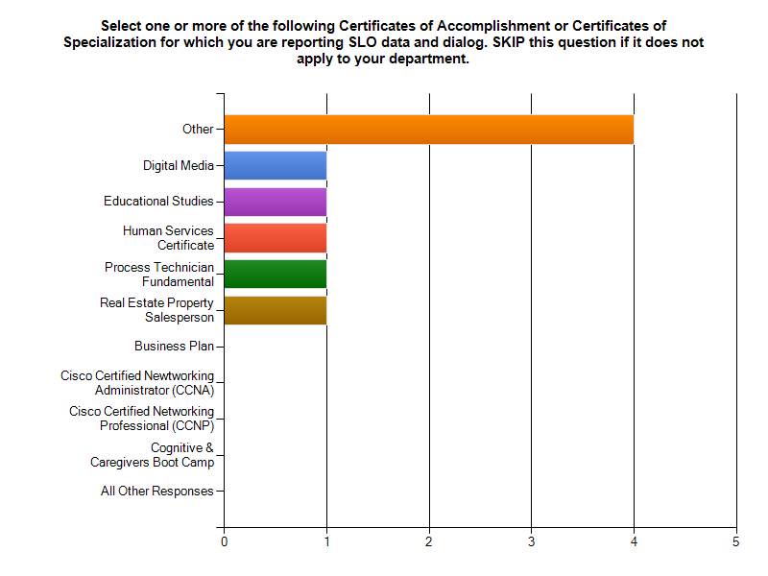
The “Other” category includes: Reading, Student Success Center, Foods/Nutrition, Health 175, Biol 100 220 225, Chemistry, Communication Studies, and Property Management.

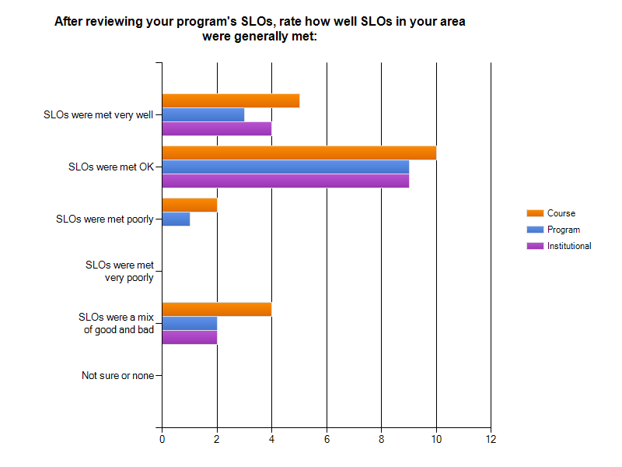
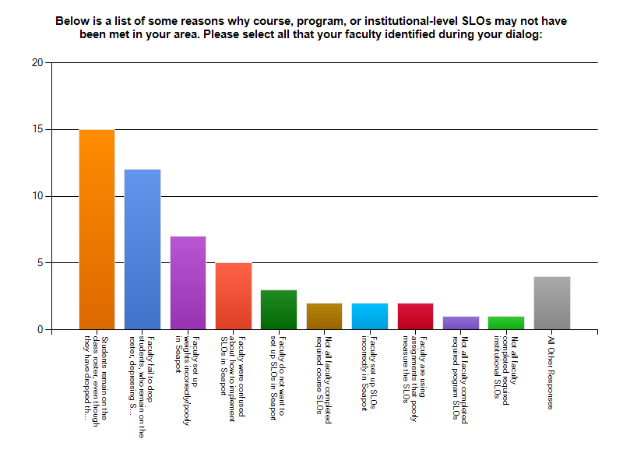
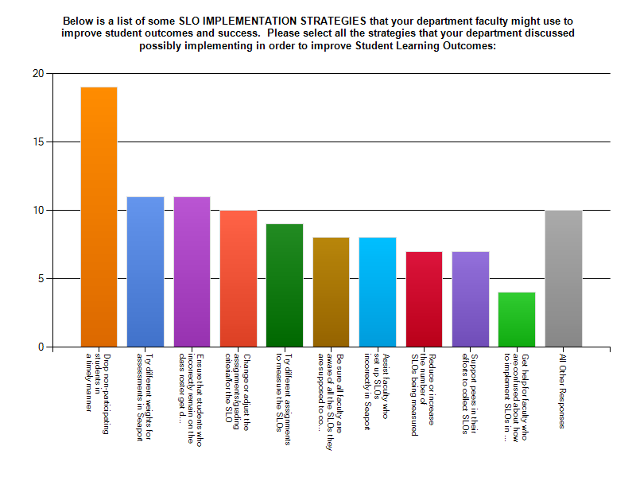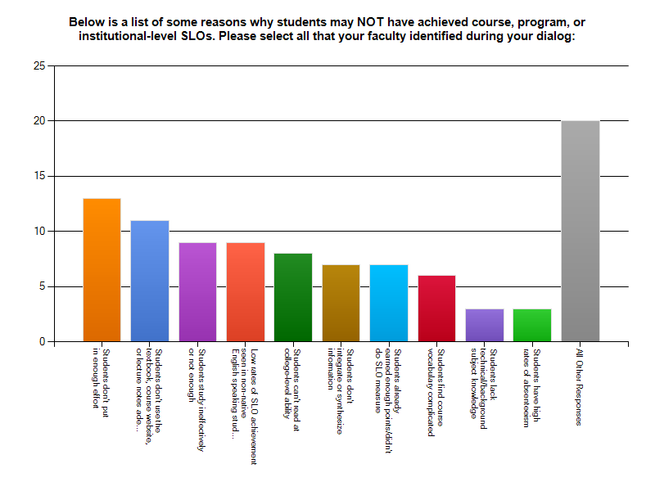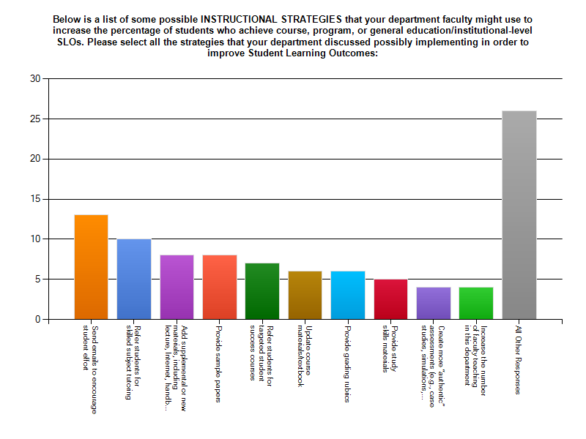
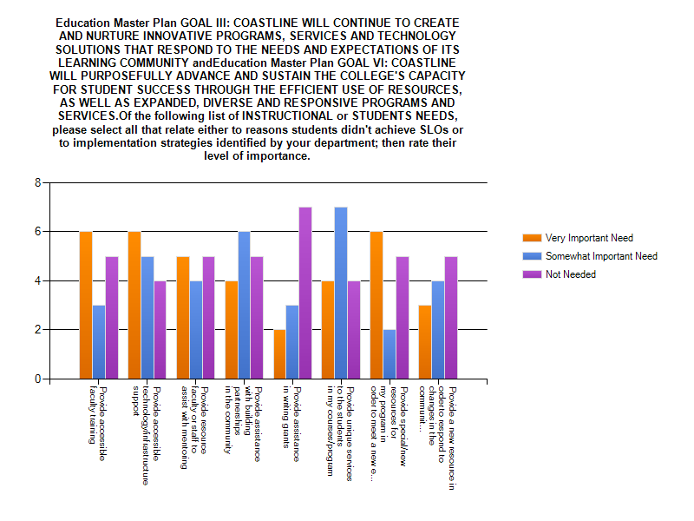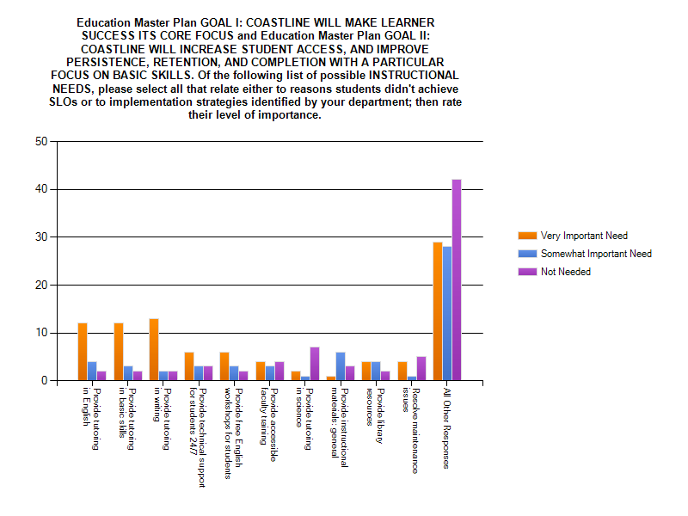

Do you have any suggestions for improving the Seaport SLO process for next year or suggestions
for how to better dialog and collect data about SLOs?

1 Interim reviews

2 Possibly a way to remove late dropping students from the statistics.

3 Need a way to report SLOs for Passkey software classes. We have a method,
but it would be nice if Passkey was connected to Seaport.

4 The president's SLO activity coming before this activity made this activity too
long. Let the faculty do this activity in their own discipline rooms, not in the
ballroom.

5 Seaport is difficult to navigate.

6 For the core courses all faculty should use the same assessments at the same
percentages. It does not help students or faculty when each instructor can pick
their own assessments and percentages for the core accounting courses (Acct
C101, Acct C102).

7 We suggested moving away from the focus on the collection of quantitative data
and more of a focus on the qualitative element. The most useful exercise for us
to improve our courses and programs and better achieve Student Learning
Outcomes would be to have time for us to talk together and share our ideas
about instruction and assessment.

8 Difficult to recognize 0 grades vs non-attempt in Seaport Grading System.

9 Great job!!

